Studying the Role of Colombia in the Israel-Palestine War through ABM, Network Analysis, and Game Theory

Joseph Martínez Salcedo

## Introduction

The president of Colombia Gustavo Petro has been actively supportive of the people of Palestine in the war with Israel, advocating for the human rights of Palestinians, accusing Israel of genocide, and even claiming that “the world must curb Netanyahu”. [1] However, on March 26 his position caused a global shock when he made allegations threatening to break ties with Israel if it does not comply with a UN cease-fire resolution [2]. As a result, Foreign Minister Israel Katz criticizes the Colombian president as a ‘disgrace’ after the threat [3].

However, the relationship between Colombia and Israel should not be taken lightly. Military analysts in Colombia have said that the deterioration of relations with Israel jeopardizes the South American nation’s defense capabilities [2]. Colombia depends on Israeli companies for the maintenance of its fleet of more than 20 Israeli-built Kfir jets, which are the only planes in Colombia’s arsenal that are capable of launching laser-guided bombs [2].

Agent-Based Models (ABMs), Network Analysis, and Game Theory play crucial roles in understanding and anticipating the complex dynamics of global discords [4] such as the one between Colombia and Israel. These tools allow policymakers and analysts to explore the possible outcomes of various decisions and strategies, helping them to make informed choices in the face of uncertainty. By simulating different scenarios, decision-makers can assess the potential consequences of their actions, including the ripple effects on diplomatic relations, military capabilities, and regional stability.

In the case of Colombia's stance towards Israel, simulation can help model the intricate web of geopolitical interactions and the interplay of economic, military, and political factors. ABMs enable the representation of diverse actors, from individual policymakers to entire nations, each with its objectives, constraints, and strategies. Network analysis allows the mapping of complex relationships between various actors, including governmental bodies, non-governmental organizations, and international alliances. Game theory provides a framework for analyzing strategic interactions between rational decision-makers, showcasing potential strategies and counterstrategies employed by different players [5].

By simulating the possible outcomes of Colombia's decision to break ties with Israel, we can evaluate the risks and benefits involved, considering not only immediate consequences but also long-term implications for Colombia's security, alliances, and international standing.

## Methodology

To study the potential outcomes of Colombia's stance on the Israel-Palestine conflict and its decision-making process, a multi-faceted approach integrating ABMs, Network Analysis and Game Theory will be employed. An ABM will be created where the agents represent different factors like nations, and international organizations, and they are interconnected in a Network array and some of the decisions taken by those agents rely on Game Theory. This methodology aims to provide a comprehensive understanding of the complex dynamics involved in global conflicts and strategic decision-making.

The ABM will simulate the interactions between various actors, including individual policymakers, nations, and international organizations, within the context of the Israel-Palestine conflict, especially actors within Latin America. Each agent will be provided with attributes such as beliefs, preferences, and decision-making algorithms, allowing for the representation of realistic behavior in response to changing circumstances. The model will consider factors such as historical alliances, economic dependencies, and political ideologies to capture the nuanced dynamics of international relations. To have a geopolitical approach in account, all the actors will be connected to each other, representing relationships between nations and organizations. In Figure 1 there is a visual representation of how agents and their relationships would look like when using Network Analysis. However, those interactions will be affected by the agent's characteristics and the decision-making of the opponents.

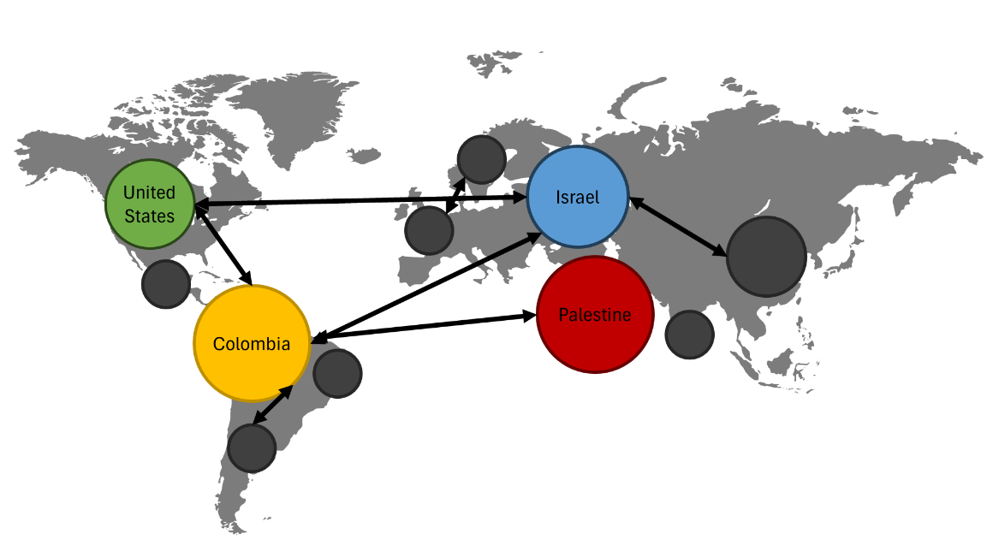

Figure 1.Visual representation of the network of players in the simulation (ABM) of the conflict.

Game Theory will be employed to analyze strategic interactions between rational decision-makers, particularly focusing on Colombia's role in the conflict and its potential strategies. It will be assumed that the players want to maximize their goals, and through the outcomes of the games between each other, the attributes and decision-making will be updated. By framing the situation as a strategic game, various scenarios and potential outcomes will be explored, considering the incentives and objectives of each actor involved. Through the application of game theoretic concepts such as Nash equilibria and dominant strategies, optimal decision paths for Colombia will be identified, aiming to maximize its interests while mitigating risks. Figure 2 shows a simplified outline of how an interaction between different countries (not necessarily Colombia and Israel directly) can be analyzed using game theory. There, we can analyze the best option of each player considering the strategies of the rivals. Implementing these outcomes in the ABM, one can have a very complex simulation with interesting results and findings.

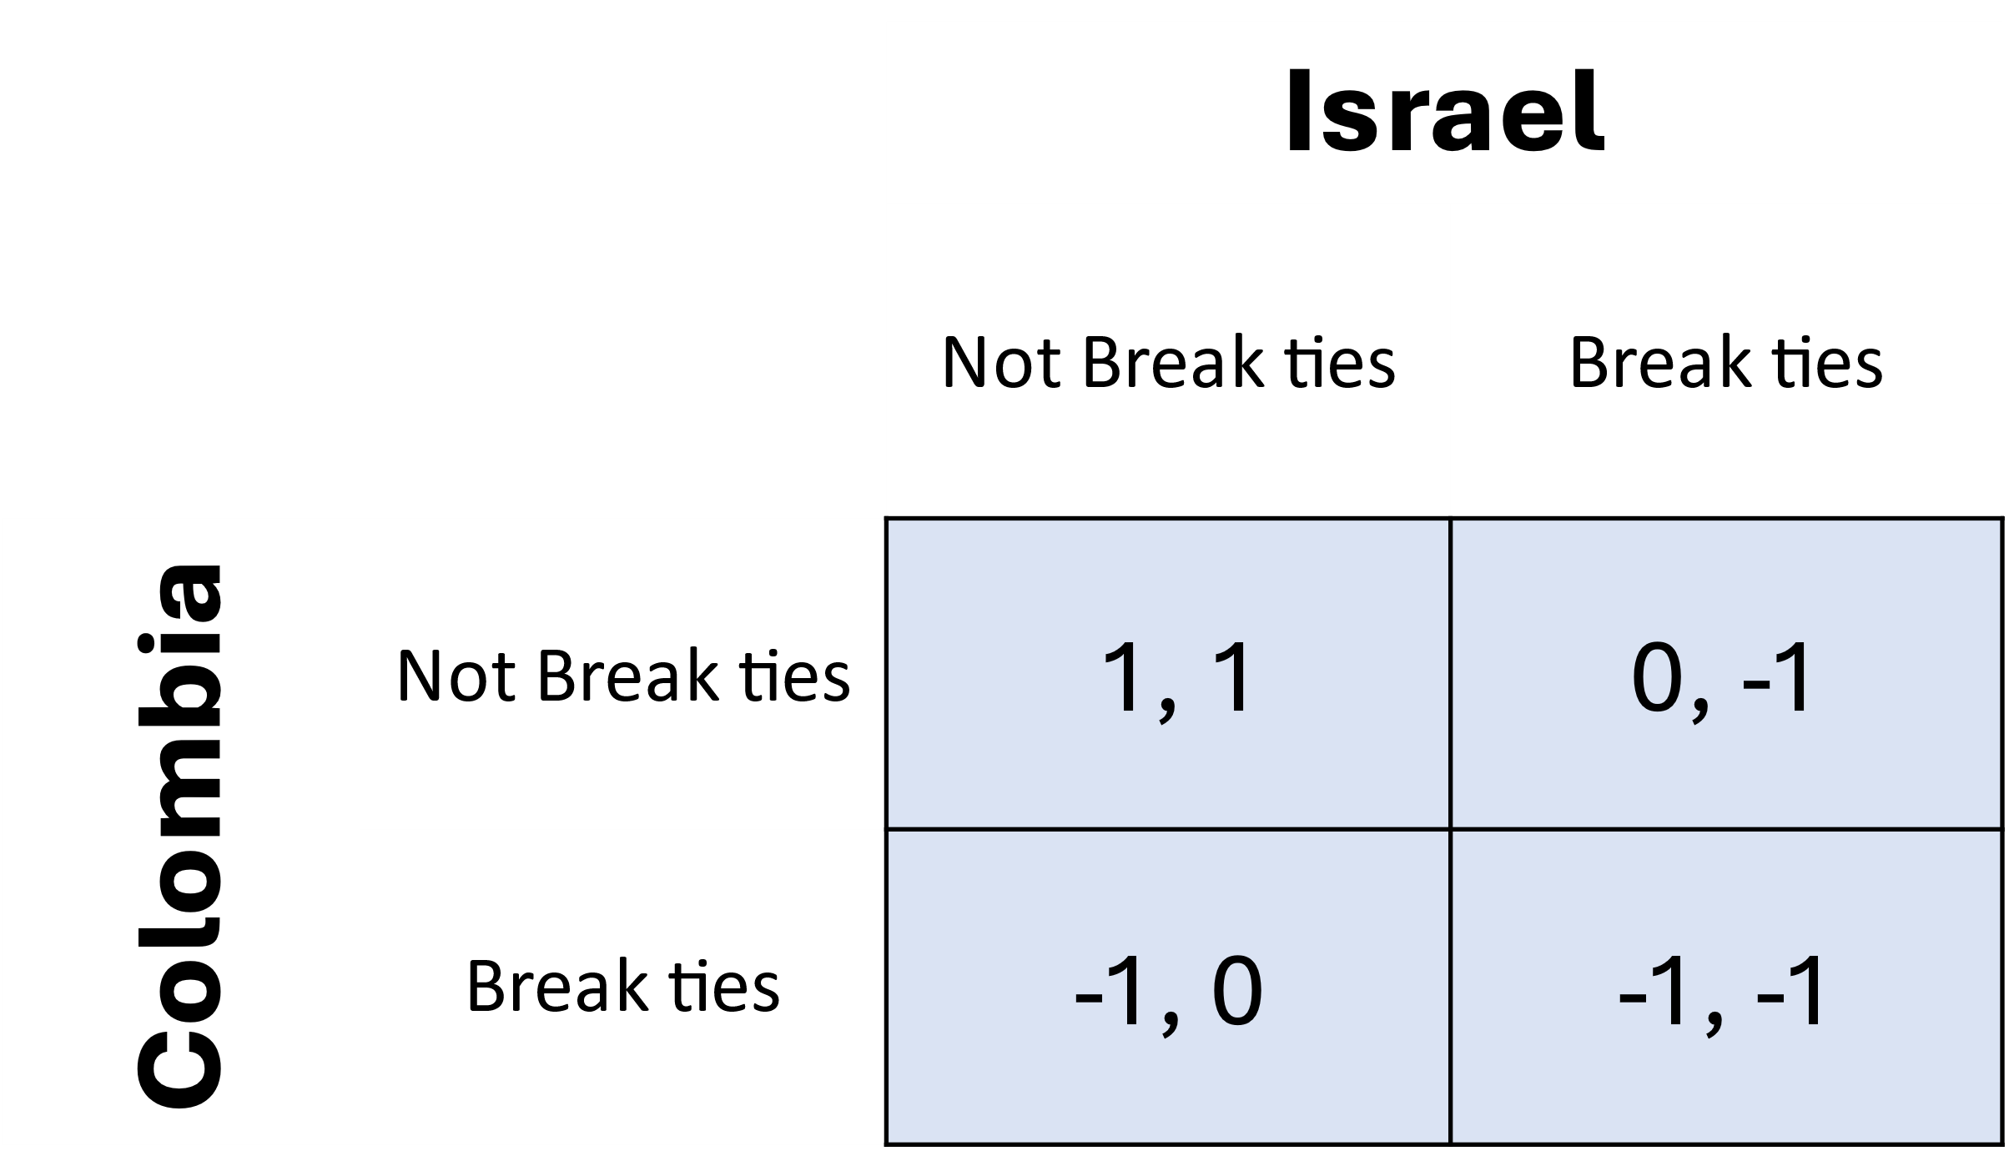

Figure 2. Visual representation of a strategic game between players in the conflict.

Data collection will involve gathering information on historical events, diplomatic relations, military capabilities, and economic dependencies relevant to the Colombia-Israel-Palestine nexus. This will involve accessing international databases such as the World Bank's repository of economic indicators and trade statistics, as well as diplomatic reports. Specific attention will be given to global economic variables and monetary exchanges between countries and companies, which play crucial roles in shaping geopolitical dynamics. This empirical data will be used to parameterize the ABM and validate the assumptions underlying the game theoretic analysis.

Quantitative analyses will be conducted to interpret the simulation results, employing statistical techniques to identify key trends, sensitivities, and trade-offs inherent in Colombia's decision-making process. The integration of diverse data sources and analytical approaches will facilitate a comprehensive understanding of the complex dynamics driving the Colombia-Israel-Palestine conflict, enhancing the validity and reliability of the research findings.

# References

1. *Petro accuses Israel of genocide, mentions Hamas, and says 'The world must curb Netanyahu'*, in *Brasil de Fato*. 2024.

2. Rueda, M., *Colombia threatens to break ties with Israel if it doesn't comply with a UN cease-fire resolution*, in *The Washington Post*. 2024.

3. *Israel slams Colombian president as a ‘disgrace’ after he threatens to cut off ties*, in *The Times of Israel*. 2024.

4. Taylor, G., et al. *Agent-based Simulation of Geo-Political Conflict*. in *AAAI Conference on Artificial Intelligence*. 2004.

5. Jameson, K. *Game Theory and its Applications*. 2014.